**Some basic command for using GIT**

**GIT have some basic Command**

**Add & Commit**

You can propose changes (add it to the **Index**) using right click at your Repository -> choose Commit  
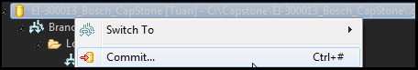

**Select which file you want to add -> insert your commit message -> commit**

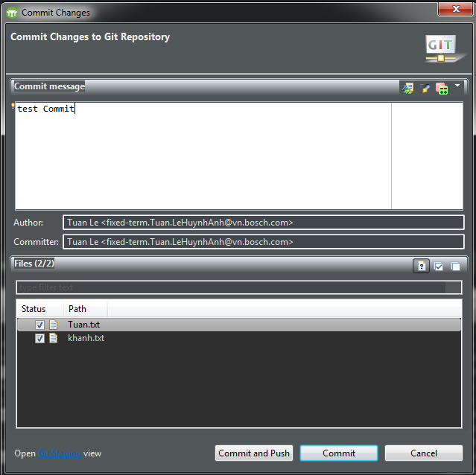

## Pushing changes

Your changes are now in the **HEAD** of your local working copy. To send those changes to your remote repository, right click at your Repository -> Push to Upstream or Push Branch ‘Tuan’ (still confuse what is different between 2 kind of push)

## Branching

Branches are used to develop features isolated from each other. The *master* branch is the "default" branch when you create a repository. Use other branches for development and merge them back to the master branch upon completion.

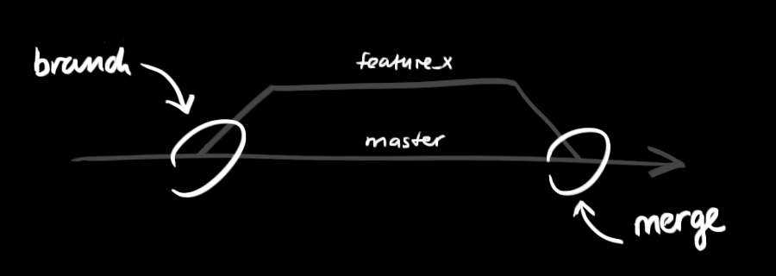

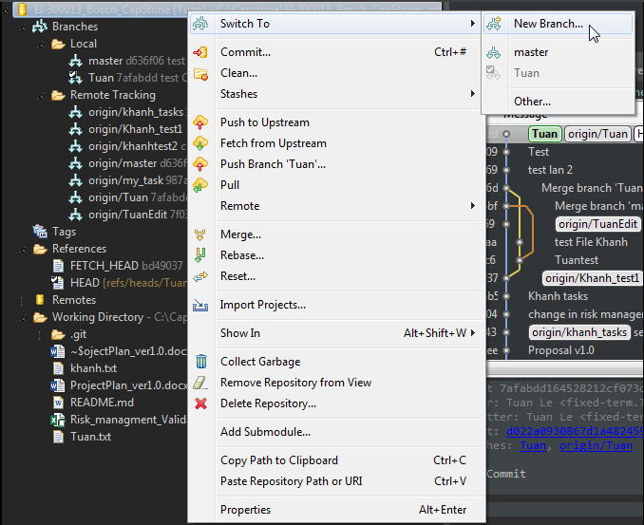Create a new branch and switch to it using right click at your repository -> Switch to -> New branch

Select..: Choose which branch you want to be source

Branch name: insert your new Branch

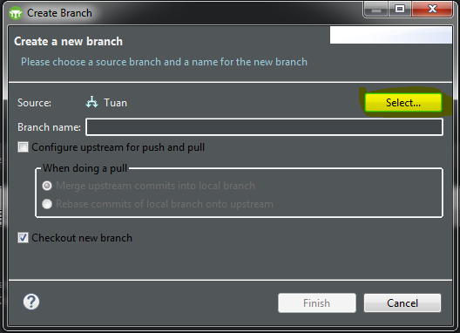

Finish

At the folder Remote Tracking have all Branch that you can get from TFS, if you want to get any Branch, double click in that branch and it will load at local branch for you. Next time when you want to change branch, you just need to double click at Name Branch at Local.

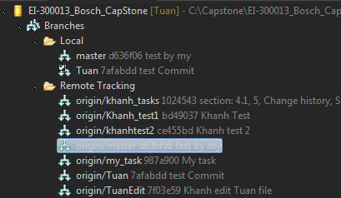

## Update & merge

To update your local repository to the newest commit, execute   
Double click at your local branch which you want to update

Right click at your local repository -> Pull

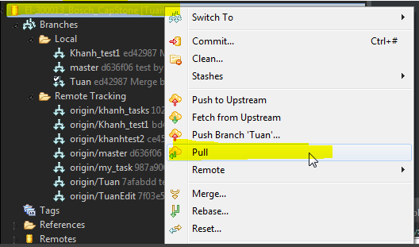

In yours working directory to *fetch* and *merge* remote changes.

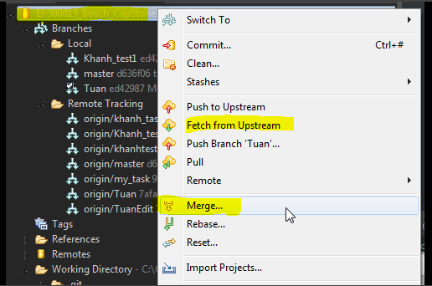

To merge another branch into your active branch (e.g. Tuan), use Right Click at Your local branch (e.g. Tuan) -> Merge

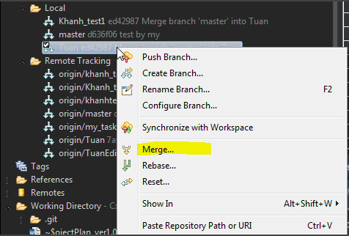

At this step, choose which branch you want to merge with

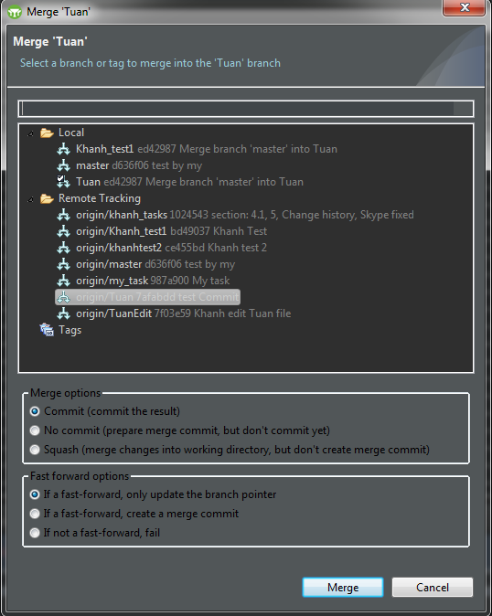

Then Click Merge

The conflict occurs when 2 person edit a same file. Then the second person can not submit because the origin file had been edited by the first person.  
Solution:  
- Pull new code.  
- Compare new code & your code to rebase code manually. (Code use Git Extension / EGit / Source Tree... Depend on your choice).  
- Commit and push code again

Some Basic Tutorial about GIT in Vietnamese: <https://backlogtool.com/git-guide/vn/>